**Defining Spring Beans with Java Code**

**Defining Beans in Spring**:

Now we define beans with Java code. We can also define beans by using XML. We will list each bean out separately. Here we define beans using Java configuration classes.

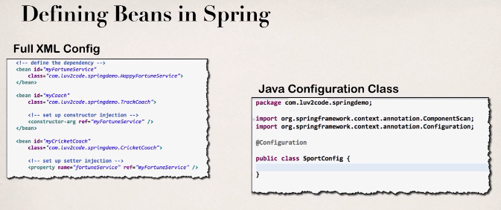

**Our new Coach**:

Now we introduce here our new coach

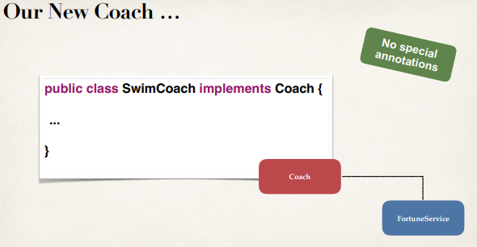

We have a Coach and we also have a FortuneService implementation. Here we will learn how to inject that FortuneService using just raw Java code.

**Development Process**:

1. Define method to expose bean
2. Inject bean dependencies
3. Read Spring Java configuration class
4. Retrieve bean from Spring container

**Step 1: Define method to expose bean**:

@Configuration

public class SportConfig {

@Bean

public Coach swimCoach() {

SwimCoach mySwimCoach = new SwimCoach();

return mySwimCoach;

}

}

**Note**:

No @ComponentScan

**Step 2: Inject bean dependencies**:

Defining Spring Beans with Java Code